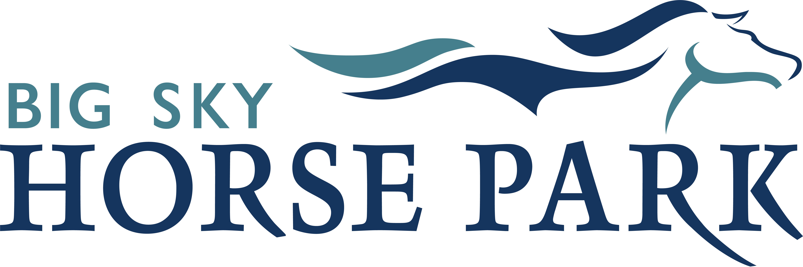

**CONTACT INFORMATION OF PRIMARY MEMBER OR GUEST:**

First Name: Last Name: Email (required): Phone: Mailing Address: __________________ City: State: Zip:

INSTRUCTORS AND CLINICIANS WISHING TO INSTRUCT AT BSHP MUST BE A MEMBER AND SUBMIT PROOF OF GENERAL LIABILITY

INSURANCE THAT LISTS MISSOULA HORSE COUNCIL dba BIG SKY HORSE PARK AND MISSOULA COUNTY AS ADDITIONAL NAMED INSURED.

I, the undersigned MHC Member, herein request access and permission to occupy, use, enjoy and/or ride or handle horses on the premises of Big Sky Horse Park, (“BSHP”). I understand and agree that whether I am participating in equine activities within BSHP premises or exposing myself to the inherent hazards or injuries associated with equine handling and activities on any part of the premises, I am doing so willingly with the understanding that horses are inherently dangerous.

Further, I understand: the purpose of MCA27-1-725 through 27-1-727 is to assist courts and juries in defining the circumstances under which persons responsible for equines may be found liable for damages to persons harmed during equine activities. It is the policy of the State of Montana that a person is not liable for damages sustained by another solely because of risks inherent in equine activities if those risks are or should be reasonably obvious, expected, or necessary to persons engaged in equine activities. It is also the policy of the State of Montana that an equine activity sponsor or equine professional who is negligent and causes foreseeable injury to a participant bears responsibility for that injury in accordance with other applicable law. Further, the undersigned acknowledges that I have had the opportunity to inspect the premises and surrounding conditions for inherent hazards associated with the nature of the premises (including icy winter conditions) each time I occupy the premises as a member, participant, spectator or invitee and therefor wish to make this acknowledgement and agreement perpetually binding from the date herein signed.

**ANNUAL MEMBERSHIP TYPE:** *All plans are for the calendar year starting January 1st through December 31st. Non-members please go to the next section. Youth = Must be 17 years or younger as of January 1st. Adult = 18 years of older as of January 1st of the current year. Family = 2 adults and any children living in the same household.*

Youth = $60

Adult = $80

Family + 1 XC = $205

Youth + XC = $135

Adult + XC = $155

Family + 2 XC = $280

Non-Rider Supporter = $25

Names of Additional Family Members:

Family/Couple = $130

Family + 3 XC = $355

The undersigned agrees that a member’s breach of MHC’s Member in Good Standing policy as defined in MHC’s Policies & Procedures constitutes a breach of this agreement and may render this agreement void and revocable at the discretion of the MHC Board of Directors.

**EQUESTRIAN GUEST PASSES:** *Non-members must be accompanied by a current BSHP member. Please fill out one form per guest.*

Please name the overseeing member:

Day Use Fee: Number of Days x $25.00 = Cross Country/Obstacle Pass: Number of Days x $25.00 =

TOTAL DAY USE FEES:

Under 18 riders must wear ASTM/SEI approved riding helmets. The use of approved and properly adjusted riding helmets, safe tack and responsible horsemanship for riders at BSHP is encouraged for all. SUPERVISING A MINOR: The below signed herein certifies I am a parent or legal guardian having full authority and acknowledge that the minor above-named, understands and accepts that they are assuming inherent risks associated with all activities that they are involved in at BSHP.

Print Name: Signature of Participant/Guardian for a Minor:

______________________________________________ 2025 MEMBERSHIP & GUEST PASS FORM *EARLY BIRD*

Form and fees may be placed in BSHP drop box -(OR)- Mail this form with check made out to: Missoula Horse Council, PO Box 3841, Missoula, MT 59806